1. 
2. Before understanding, what is Spring Data JPA, let’s try to understand what problems we were facing before Spring Data JPA and what it tries to solve.
3. **Above we have 3-Layer architecture** 🡺 Controller, Service, DAO.
4. **See how much code we have to write when using Hibernate**: We will take example of Customer Entity.  
   🡺 Create CustomerDAO.java  
   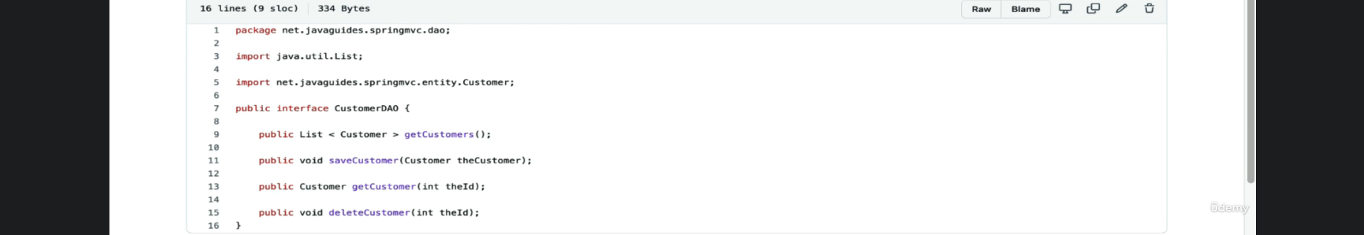  
   🡺 **Then Create its implementation**:  
   A red arrow with white text

   Description automatically generated with low confidence  
     
   This is what Spring Data JPA does. It keeps the generic code at a place in a library.
5. A screenshot of a computer

   Description automatically generated with low confidence
6. Spring Boot Team has developed a library called Spring Data JPA to reduce the amount of boilerplate code that is required to develop DAO Layer.
7. A screenshot of a computer

   Description automatically generated with medium confidence
8. A close up of a document

   Description automatically generated with low confidence
9. A close up of a document

   Description automatically generated with low confidence
10. A picture containing text, screenshot, design

    Description automatically generated